The Hudson Valley Sciontists

will look inside The Cardboard Box.

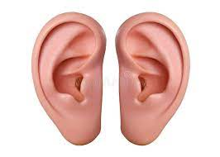

examine the Adventure,

and, perchance, discuss the anatomy of the human ear.

When? Sunday, May 23, 2021 at 4PM

Where? Just follow the link:

Join Zoom Meeting
https://us02web.zoom.us/j/89431453236
Meeting ID: 894 3145 3236
One tap mobile
+19292056099,,89431453236# US (New York)
+13017158592,,89431453236# US (Washington DC)
Dial by your location
+1 929 205 6099 US (New York)
+1 301 715 8592 US (Washington DC)
+1 312 626 6799 US (Chicago)
+1 253 215 8782 US (Tacoma)
+1 346 248 7799 US (Houston)
+1 669 900 6833 US (San Jose)
JCR/2021

