The Game is Afoot

At Vassar College Alumnae House
Raymond Avenue, Poughkeepsie, NY

Sunday, October 19, 2008 at 5:00 pm, when

The Hudson Valley Sciontists

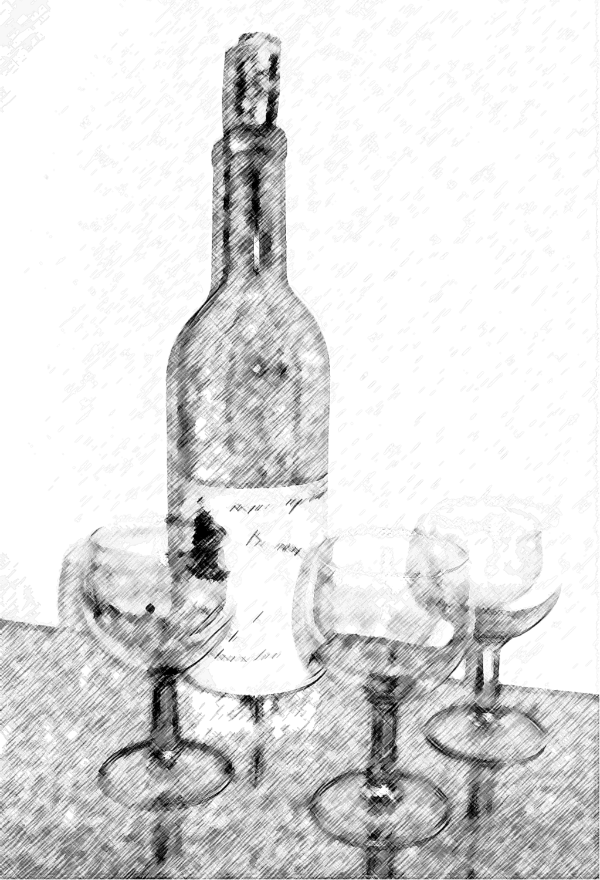
meet to discuss

The Adventure of
The Abbey Grange

We welcome brief observations about any aspect of this story

$40.00 per person for dinner
cash bar

RSVP with check:
Lou and Candy Lewis, 2 Loockerman Ave, Poughkeepsie, NY 12601.
Phone: (845) 471-0296.
Email: CLewis1880@aol.com

